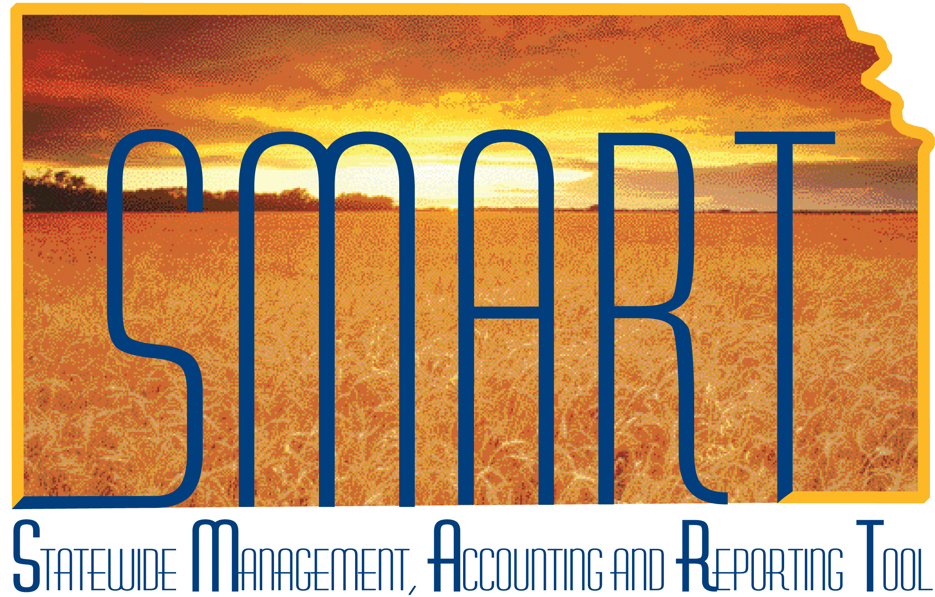

Training Guide – Vendors
1099 and Withholding Information

State of Kansas

Applicable Role(s):

Agency Vendor Processors
Table of Contents
1099 Information 3
Guide to completing the Withholding Vendor Information page 4
SMART 1099 Account Code Guide 6
Vendors – Location Page 13
1099 Types and Class Information 15
Adding a New Location: 19

1099 Information

What is a 1099? It is an informational return to report various type of income other than wages.
The IRS requires the State of Kansas to issue 1099’s to reportable entities (vendors) for services, rentals, awards, certain type of grants, interest, dividends, and certain real estate purchases.
The State of Kansas, Department of Administration submits five types of 1099 Forms to the IRS:
- 1099-MISC: Services, rents, awards
- 1099-G: Governmental payments (tax refunds are the Dept of Revenue)
- 1099-INT: Interest
- 1099-DIV: Dividends
- 1099-S: Real estate
Two criteria must be met in order for 1099 reporting to occur for a vendor:
- The vendor must be subject to 1099 reporting
- The payment must be reportable
What vendors are NOT (currently) reportable?
- Corporations are NOT reportable UNLESS they provide medical or legal services
- Governments
- Tax Exempt Organizations
What is LLC?
LLC stands for Limited Liability Company. The federal government does not recognize an LLC as a classification for federal tax purposes. An LLC can be a corporation, partnership or sole proprietorship. The W-9 Form should indicate the Type of entity the vendor is.

Guide to completing the Withholding Vendor Information page

- SMART will not allow you to save a vendor record if you enter the ACH information in BEFORE entering the 1099 information. Ensure you complete the Address Tab before the Location Tab when setting up a new vendor record in SMART.
- Withholding Vendors
Complete the 1099 Information section AND the 1099 Reporting Information section.
Examples:
  - Medical Corporations
  - Attorneys
  - LLC – Limited Liability Company

- Non-Withholding Vendors
Complete only the 1099 Reporting Information section.
Examples:
  - Incorporated
  - Corporation
  - Foreign Vendors

Examples of Reportable Payments
FORM 1099 MISC - EXAMPLES OF REPORTABLE PAYMENTS
RENTS (Form 1099-MISC, Box 1) | NON-EMPLOYEE COMPENSATION
Office Space | (Form 1099-MISC, Box 7)
Parking Lot Space | Accountants/Auditors
Welfare Rental Assistance (to Landlords) | Advertising Services
Equipment | Appraisers
Surface Royalties | Architects
Real Property | Armored Car Services
Other Property | Attorneys* (who are not your employees)
 | (Includes Corporations)*
 | Auto Repair
ROYALTIES (Form 1099-MISC, Box 2) | Board Members
Literary rights | Chaplains
Copyrights | Cleaning Services
Publishing Licensing fees | Commercial Repairs – Hwy Vehicles
 | Computer Programming
 | Computer Repairs
OTHER INCOME (Form 1099-MISC, Box 3) | Construction Services
Awards (Nonemployee) | Consultants
Prizes (Nonemployee) | Contracted Repairs
 | Court Appointed Workers
 | Court Reporters
MEDICAL & HEALTH CARE SERVICES | Custodial / Maintenance
(Form 1099-MISC, Box 6, includes all payments | Design & Testing
to Medical Service Corporations) | Engineers
Ambulance Services | Evaluation Consultant
Dentists/Dental Services | Expert Witnesses
Doctors/Medical Services | Extermination Services
Hospitals** | Graphic Artist
(**except if tax exempt or owned/operated by a | Institution Contracts
governmental entity) | Janitorial Services
Lab Services | Keypunch Services
Optometrists | Landscapers, Locksmiths
Private Duty Nurses | Laundry Services
Psychiatrists, Psychologists | Maintenance Agreements
Rehabilitation Centers | Non-Employee Allowance
Therapists | Occasional Salaries & Wages (to Non-Employees)
Hospitalization | Parcel & Delivery Services
All payments to Medical Service Corporations | Photographers
 | Printing Services
 | Prison Labor Allowance
GROSS PROCEEDS PAID TO AN ATTORNEY | Professional Service Payments
(Form 1099-MISC, Box 14) | Protection Services
Gross proceeds paid to an attorney | Security Services
in connection with legal services. | Teacher/Instructor (Non-Employee)
 | Trash Removal
 | Working Interest - Oil and Gas Payments
FORM 1099-INT, 1099-DIV, 1099-G and 1099-S
EXAMPLES OF REPORTABLE PAYMENTS
INTEREST (Form 1099-INT, Box 1) |  | DIVIDENDS (Form 1099-DIV, Box 1)
Interest income |  | Distributions, such as dividends, capital gain distributions,
 |  | or nontaxable distributions, that were paid on stock,
 |  | and liquidation distributions.
TAXABLE GRANTS (Form 1099-G, Box 6) |  | PROCEEDS FROM REAL ESTATE (Form 1099-S, Box 2)
Taxable Grants |  | Gross Proceeds from the sale or exchange of real estate

SMART 1099 Account Code Guide

Note: Titles are presented as they appear in SMART (field length limits)

SMART Account | STARS Esobj | Title | 1099 TYPE | 1099 Class | Notes
523100 | 2310 | REPROGRAPHIC EQUIPMENT RENTAL | 1099 | 01
523200 | 2320 | BUILDING SPACE RENTAL | 1099 | 01
523300 | 2330 | EQUIPMENT RENTAL | 1099 | 01
523400 | 2340 | LAND RENTAL | 1099 | 01
523600 | 2360 | INFORMATION PROCESSING EQUIPMENT RENTAL | 1099 | 01
523700 | 2370 | INFORMATION PROCESSING SOFTWARE RENTAL | 1099 | 01
523900 | 2390 | OTHER RENTALS | 1099 | 01
524101 | 2410 | REPAIR AND SERVICE - PASSENGER CARS | 1099 | 07
524201 | 2420 | REPAIR AND SERVICE - OTHER SELF-PROPELLED EQUIP | 1099 | 07
524300 | 2430 | REPAIR AND SERVICE - MACHINERY,EQUIPMENT,FURNIT | 1099 | 07
524400 | 2440 | REPAIR AND SERVICE - BUILDINGS AND GROUNDS | 1099 | 07
524501 | 2450 | REPAIR AND SERVICE-HIGHWAYS AND BRIDGES (276, 7 | 1099 | 07
524700 | 2470 | INFORMATION PROCESSING EQUIPMENT REPAIR & SERVI | 1099 | 07
524800 | 2480 | INFORMATION PROCESSING EQPT SOFTWARE MAINT & SE | 1099 | 07
524900 | 2490 | REPAIR AND SERVICE - NOT OTHERWISE CLASSED | 1099 | 07
525120 | 2521 | HIRE OF CARS, PLANES, BUSES FOR IN-STATE TRAVEL | 1099 | 01 | Taxable if paid direct to vendor
525130 | 2531 | STATE CAR EXPENSE FOR IN-STATE TRAVEL | see note |  | Repairs are taxable if paid direct to vendor, supplies are not
525170 | 2571 | RAIL, PLANE, BUS FARES - IN-STATE TRAVEL | 1099 | 07 | Taxable if paid direct to vendor
525180 | 2581 | LODGING | 1099 | 01 | Taxable if paid direct to vendor
525190 | 2591 | NONSUBSISTENCE ITEMS FOR IN-STATE TRAVEL | see note |  | Taxable if paid direct to vendor; conference registration 1099 class 03
525220 | 2522 | HIRE OF CARS, PLANES, BUSES - OUT-OF-STATE TRAVEL | 1099 | 01 | Taxable if paid direct to vendor
525230 | 2532 | STATE CAR EXPENSE FOR OUT-OF-STATE TRAVEL | see note |  | Repairs are taxable if paid direct to vendor, supplies are not
525270 | 2572 | RAIL, PLANE, BUS FARES - OUT-OF-STATE TRAVEL | 1099 | 07 | Taxable if paid direct to vendor
525280 | 2582 | LODGING | 1099 | 01 | Taxable if paid direct to vendor
525290 | 2592 | NONSUBSISTENCE ITEMS FOR OUT-0F-STATE TRAVEL | see note |  | Taxable if paid direct to vendor; conference registration 1099 class 03
525320 | 2523 | HIRE OF CARS, PLANES, BUSES - INTERNATIONAL TRAVEL | 1099 | 01 | Taxable if paid direct to vendor
525330 | 2533 | STATE CAR EXPENSE FOR INTERNATIONAL TRAVEL | see note |  | Taxable if paid direct to vendor
525370 | 2573 | RAIL, PLANE, BUS FARES - INTERNATIONAL TRAVEL | 1099 | 07 | Repairs are taxable if paid direct to vendor, supplies are not
525380 | 2583 | LODGING | 1099 | 01 | Taxable if paid direct to vendor
525390 | 2593 | NONSUBSISTENCE ITEMS FOR INTERNATIONAL TRAVEL | varies |  | Taxable if paid direct to vendor
526200 | 2620 | HONORARIUMS | 1099 | 07 | in some cases could be class 03
526320 | 2632 | COMPUTER PROG AND DATA PROCESS-VENDORS O/T DISC | 1099 | 07
526330 | 2633 | DATABASE ACCESS FEES-VENDORS OTHER THAN DISC | 1099 | 07
526400 | 2640 | RECORDING FEES, SERVICING, AND COURT COSTS | 1099 | 07
526500 | 2650 | LABORATORY FEES | 1099 | 07
526700 | 2670 | BOARDING HOME PAYMENTS | 1099 | 01
526800 | 2680 | MAINTENANCE AND TUITION FOR REHABILITATION CLIE | 1099 | 07
526900 | 2690 | OTHER FEES | 1099 | 07
526910 | 2691 | CREDIT CARD FEES AND CHARGES | 1099 | 07
526920 | 2692 | BANK FEES CHARGED BY CONTRACTOR BANKS-REIM TREAS. | 1099 | 07
526960 | 2696 | E-CHECKS FEES AND CHARGES | 1099 | 07
526970 | 2697 | MILITARY ACTIVATION PAYMENT | 1099 | 03
527100 | 2710 | ARCHITECTS AND ENGINEERS | 1099 | 07
527200 | 2720 | ATTORNEYS AND LAWYERS | 1099 | 07
527300 | 2730 | PHYSICIANS AND MEDICAL ASSOCIATIONS | 1099 | 06
527400 | 2740 | HOSPITALS AND NURSING HOMES | 1099 | 06
527500 | 2750 | ADVERTISING AGENCIES | 1099 | 07
527600 | 2760 | VETERINARIANS | 1099 | 07
527700 | 2770 | LECTURERS, SPEAKERS AND ENTERTAINERS | 1099 | 07
527800 | 2780 | ACCOUNTANTS AND AUDITORS | 1099 | 07
527910 | 2791 | INFORMATION SYSTEMS CONSULTING FEES | 1099 | 07
527990 | 2700 | ADMINISTRATIVE SERVICES | 1099 | 07
527990 | 2790 | professional services | 1099 | 07
529200 | 2920 | LAUNDRY, DRY CLEANING AND TOWEL SERVICE | 1099 | 07
529500 | 2950 | NON-EMPL REWARDS,PREMIUMS & BOUNTIES-IRS REPORT | 1099 | 03
529500 | 2950 | NON-EMPL REWARDS,PREMIUMS & BOUNTIES-IRS REPORTABL | 1099 | 03
529500 | 2954 | NON-EMPL AWARDS,REWARDS,PREMIUMS &BOUNTIES-NOT IRS
542010 | 4200 | BUILDINGS AND IMPROVEMENTS | 1099 | 07
542090 | 4209 | BUILDINGS AND IMPROVEMENTS- NON-INVENTORY | 1099 | 07
543100 | 4310 | LAND AND INTEREST IN LAND | 1099S | 01 | Reportable if Agency is Closing Agent
543190 | 4319 | LAND AND INTEREST IN LAND - NON-INVENTORY | 1099S | 01 | Reportable if Agency is Closing Agent
544010 | 4450 | BLDGS & GRNDS- LAND IMPROVE (CAPITAL/INV) IRS | 1099 | 07
544090 | 4459 | BLDGS & GRNDS- LAND IMPROVE (CAPITAL/NONINV) IR | 1099 | 07
552040 | 5204 | INTEREST INCOME ON UNCLAIMED PROPERTY (670 ONLY | 1099I | 01
552050 | 5205 | DIVIDEND INCOME ON UNCLAIMED PROPERTY (670 ONLY | 1099D | 01
552060 | 5206 | ROYALTY INCOME ON UNCLAIMED PROPERTY (670 ONLY) | 1099 | 02
552400 | 5240 | WORKERS' COMPENSATION CLAIMS(AGENCY 173 & 331 ONLY |  |  | Not reportable
552400 | 5241 | GROSS PROCEEDS PAYMENTS TO ATTORNEYS FOR WORKERS | 1099 | 14 | Reportable
552700 | 5270 | CIVIL RIGHTS CONCILIATION CLAIMS | 1099 | 03
552700 | 5271 | GROSS PROCEEDS PAYMENTS TO ATTORNEYS FOR CIVIL | 1099 | 14
552800 | 5280 | PROMPT PAYMENT ACT INTEREST PENALTIES | 1099I | 01
552900 | 5290 | OTHER CLAIMS
552900 | 5291 | GROSS PROCEEDS PAYMENTS TO ATTORNEYS FOR OTHER | 1099 | 14
552900 | 5292 | OTHER CLAIMS - NON WAGE PAYMENTS | 1099 | 03
555100 | 5510 | DIRECT STATE WELFARE ASSISTANCE (AGY 039,629 ON | 1099 | 07
555100 | 5514 | STATE WELFARE ASSISTANCE-NOT SETOFF,NOT IRS REPORT |  | none
555110 | 5511 | DIRECT STATE WELFARE ASSISTANCE-SETOFF,NOT IRS REP |  | none
555110 | 5512 | STATE WELF ASST-SETOFF,IRS REP(171 & 629 ONLY) | 1099 | 07
555150 | 5515 | STATE WELF ASST-RENT,SETOFF,IRS REP(171 & 629 O | 1099 | 01
555160 | 5516 | STATE WELF ASST-MED&HLTH PAY IRS REP(039,171,35 | 1099 | 06
555200 | 5520 | DIRECT FED WELFARE ASST-AGY 039,171,629 ONLY | 1099 | 07
555200 | 5524 | FEDERAL WELFARE ASSISTANCE-NOT SETOFF,NOT IRS REPO
555210 | 5521 | FEDERAL WELFARE ASSISTANCE-SETOFF,NOT IRS REP
555210 | 5522 | FED WELFARE ASST-SETOFF,IRS REP(171, & 629 ONLY | 1099 | 07
555250 | 5525 | FED WELFARE ASST-RENT,SETOFF,IRS REP(171, 629 O | 1099 | 01
555260 | 5526 | FED WELF ASST-MED&HLTH PAY SETOFF IRS REP(039,1 | 1099 | 06
555850 | 5585 | HOUSING ASSISTNCE PAYMNTS-DEBT SETOFF IRS REPOR | 1099 | 01
555900 | 5590 | OTHER STATE SPECIAL GRANTS (206,300,350,629,683)
555900 | 5590 | OTHER SPECIAL GRANTS-IRS REPORTABLE | 1099G | 05
555900 | 5591 | OTHER SPECIAL GRANTS-IRS REPORTABLE | 1099G | 06
555900 | 5596 | OTHER SPECIAL GRANTS-IRS REP MED & HLTH PAYMENTS | 1099G | 06
559200 | 5920 | ROYALTY PAYMENTS | 1099 | 02
559400 | 5940 | KANSAS BREEDING DEVELOPMENT SUPPLEMENTS(553 ONL | 1099 | 03
559500 | 5950 | INT INCOME:APPL DEP REF(553),BUS TAX REF(565) O | 1099I | 01
559800 | 5980 | AGRICULTURAL CONSERVATION PROG PMTS(634 ONLY) | 1099G | 06

Vendors – Location Page

Page name | Navigation
Withholding Vendor Information | Vendors > Vendor Information > Add/Update (Find An Existing Value - Enter Search Criteria and Search) > Search Results > Select the desired result > Click the Location Tab > Click the 1099 Link > Withholding Vendor Information page

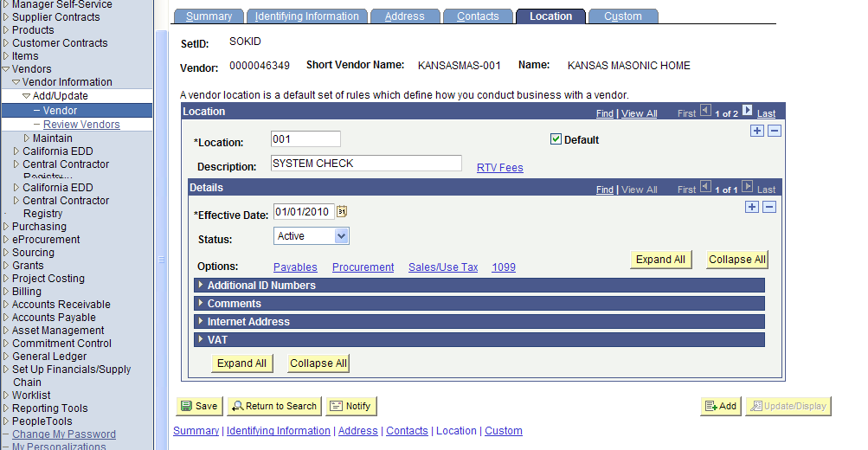
Figure 3.24. Vendor Location Tab – 1099 Link
Click the 1099 link on the vendor Location page to open the Withholding Vendor Information page.

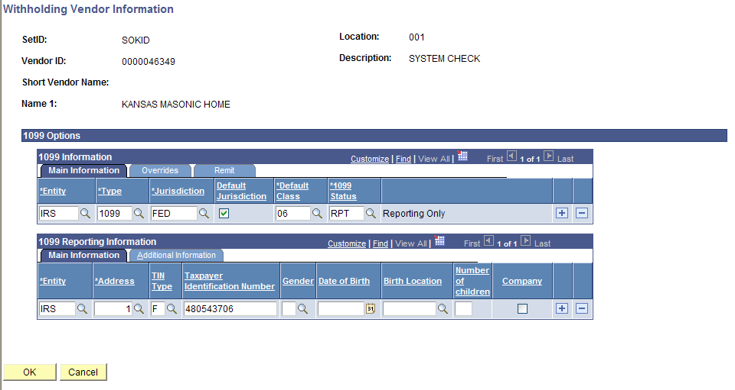
Figure 3.25. Withholding Vendor Information page
Important! You must check the Withholding checkbox on the vendor Identifying Information tab if the vendor is subject to 1099 reporting.
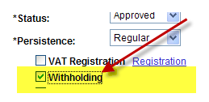
Figure 3.26. Vendor Identifying Information page – Withholding Checkbox
Important: You will receive a ‘fatal error’ message from SMART if….
You selected the Withholding checkbox on the Identifying Information tab, but you did NOT complete the information in the Withholding Vendor Information page, AND you try to Save the vendor record.
In this case, SMART will NOT allow you to save the vendor record; and you will have to enter ALL of the vendor information again!

1099 Types and Class Information
  - Each vendor Location needs at least one 1099 set up
  - The *Type and *Default Class will initially populate on a Voucher when it is created
  - Each Location should only have one *Type
  - When setting up the 1099 information for a vendor, set up all the *Default Classes you anticipate the vendor may use
Fields | Description
1099 Information Section  Main Information Tab  *Entity | Agencies: Select the ‘IRS’ option.  Agencies: Do NOT use any other option.
1099 Information Section  Main Information Tab  *Type | Select the correct Type of withholding. For each withholding type, there may be classes and categories associated with the type.  Values include: 1099, 1099D, 1099G, 1099I, and 1099S.
1099 Information Section  Main Information Tab  *Jurisdiction | Select the Withholding Jurisdiction for this type of withholding
1099 Information Section  Main Information Tab  Default Jurisdiction Checkbox | Indicate which jurisdiction is the default by selecting the check box in that jurisdiction's row. You can select more than one row as the default jurisdiction.
1099 Information Section  Main Information Tab  *Default Class | Select one of the following withholding classes for the type of withholding:  Reportable:  - 01 Rental  - 02 Royalties  - 03 Prizes, Awards, other  - 06 Medical, including medical laboratory service  - 07 Services including legal  - 14 Gross Proceeds:  - Payments made to an attorney as part of a legal settlement or court order.  - Gross proceeds may be issued in the names of the attorney and the client.  - Gross proceeds may include an amount for the attorney’s services.  -If you can determine the amount of attorney fees included in the gross proceeds, report the fee in box 7 and nothing in box 14.  Agencies – Do NOT select any of the other values from the list.  Not Reportable:  - Examples: Commodities and refunds
1099 Information Section  Main Information Tab  *1099 Status | Select the withhold status for this withholding class combination and vendor location. Select the RPT – Reporting Only option.
1099 Information Section  Main Information Tab  + button | Click the + button to add a NEW *Type for the vendor
1099 Information Section  Main Information Tab  ‘-‘ button | Agencies – Do NOT use the – button. This button is for use by the Central Vendor Processor only.  Submit a TM-21 Form to the Central Vendor Processor to have vendor information removed.
1099 Information Section  Overrides Tab | Agencies – Do NOT use the Overrides Tab. The State of Kansas is not using this functionality.
1099 Information Section  Remit Tab | Agencies – Do NOT use the Remit Tab. The State of Kansas is not using this functionality.
1099 Reporting Information  Main Information  *Entity | Agencies: Select the ‘IRS’ option.  Agencies: Do NOT use any other option.
1099 Reporting Information  Main Information  *Address | Select the vendor's address from the addresses defined on the Vendor Information - Address page. The entity needs the vendor's address.  Note: The Address field defaults the value of “1”. Change the Address code if this is not correct.
1099 Reporting Information  Main Information  TIN Type | Select the Taxpayer Identification Number (TIN) type for the vendor from these options:  F = Federal Employer ID Number  S = Social Security Number
1099 Reporting Information  Main Information  Taxpayer Identification Number | Enter the vendor's valid 9 digit TIN for the withholding entity. If you enter any number with less, or more than, 9 digits, you will receive an error message and you will not be allowed to Save the vendor record.  For Foreign vendors, enter the word ‘FOREIGN’ in the TIN field. Foreign vendors are entered manually ONLINE in SMART only, they cannot be uploaded using an interface. Any ACH payments to FOREIGN banks are entered ONLINE only. If a foreign vendor does not have a TIN #/W-9 Form, please obtain a W-8 form to send to the Central Vendor Processor.  For Federal vendors, enter ‘FED’ in the TIN field  For all other types of vendors that do not meet one of the above TIN types criteria, enter ‘OTH’.  Note: For security purposes, SMART encrypts the entire TIN number with “*’s” when the TIN field contains 9 numeric characters.  SMART does not allow you to Save the vendor record if you attempt to enter anything else in the TIN field.
1099 Reporting Information  Main Information  Gender | Agencies – Do NOT use the Gender field. The State of Kansas is not using this field.
1099 Reporting Information  Main Information  Date of Birth | Agencies – Do NOT use the Date of Birth field. The State of Kansas is not using this field.
1099 Reporting Information  Main Information  Birth Location | Agencies – Do NOT use the Birth Location field. The State of Kansas is not using this field.
1099 Reporting Information  Main Information  Number of children | Agencies – Do NOT use the Number of Children field. The State of Kansas is not using this field.
1099 Reporting Information  Main Information  Company Checkbox | Agencies – Do NOT use the Company Checkbox. The State of Kansas is not using this checkbox.
1099 Reporting Information  Main Information  + button | Click the + button to ADD a new line of information.
1099 Reporting Information  Main Information  ‘-‘ button | Agencies – Do NOT use the – button. This button is for use by the Central Vendor Processor only.  Submit a TM-21 Form to the Central Vendor Processor to have vendor information removed.
1099 Reporting Information  Additional Information Tab | Agencies – Do NOT use the Additional Information tab. The State of Kansas is not using this tab.
OK button | Once you have added the information on the Withholding Vendor Information page, click the OK button to save your changes
Cancel button | If you do NOT want to save the information you added to the Withholding Vendor Information page, click the Cancel button to cancel the changes you made.

Adding a New Vendor Location

- You can search for an existing vendor by Vendor ID, Name, or Withholding Tax ID
- Click the “SEARCH” button
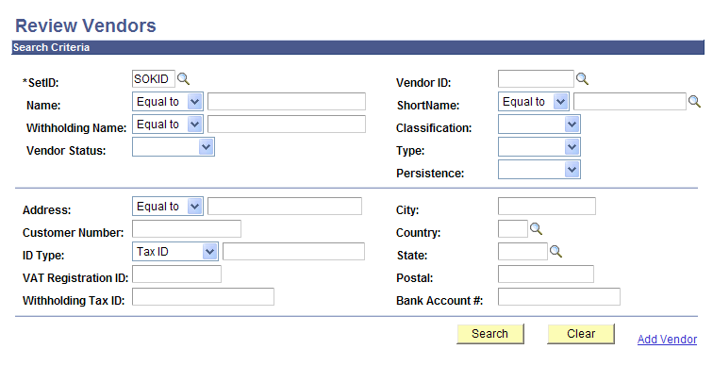
Figure 3.27. Review Vendor page

- The vendor record, Summary page is displayed. Select the Location Tab.

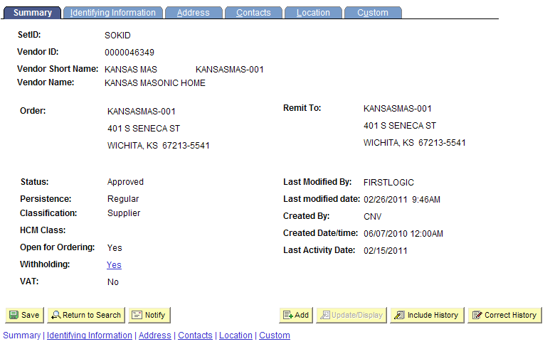
Figure 3.28. Vendor Page – Location Tab (Outlined)
- The Vendor Location page is displayed. Location 1 is displayed. Be sure to review all existing location records PRIOR to adding a NEW location !
- To ADD a new location, click on the “+” button.
  - If all addresses associated with the vendor require payments as “SYSTEM CHECK” (paper check), you do NOT need to add a new location.
  - If a vendor wants an ACH payment (direct bank account payment), and the existing record is only a “SYSTEM CHECK”, a new location needs to be set up.

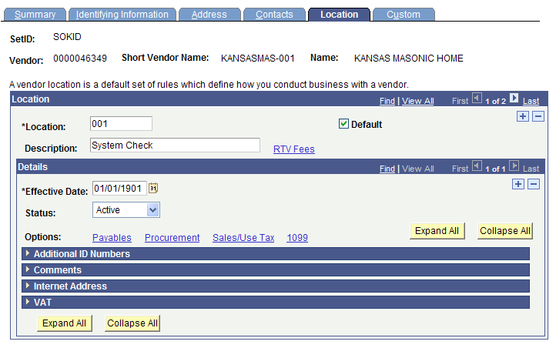
Figure 3.29. Location Page (Detail) – Add a New Location Button (Outlined)
*Location: Enter desired location number. For example: ‘002’
Description: Enter ‘ACH ****XXXX’ (where XXXX is the last 4 digits of the bank account number)
Effective Date: <today’s date> (SMART default value)
Click on the Payables Link
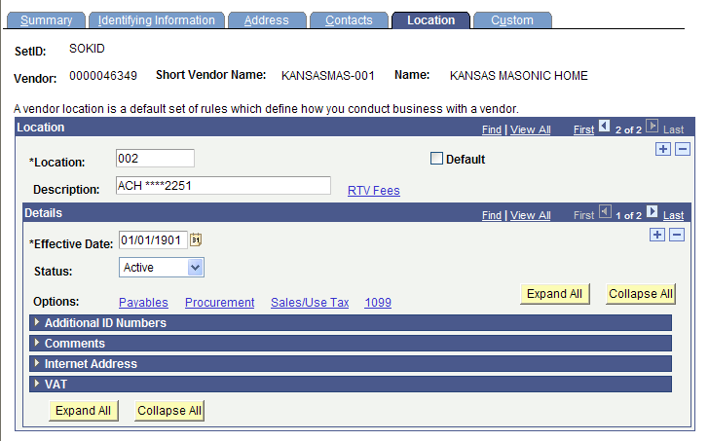
Figure 3.30. Location Page (Detail) – Add a new vendor location (data entry required)
On the Payables Option page, click the Expand Section button (triangle button to the left of the title) for the Additional Payables Options section.

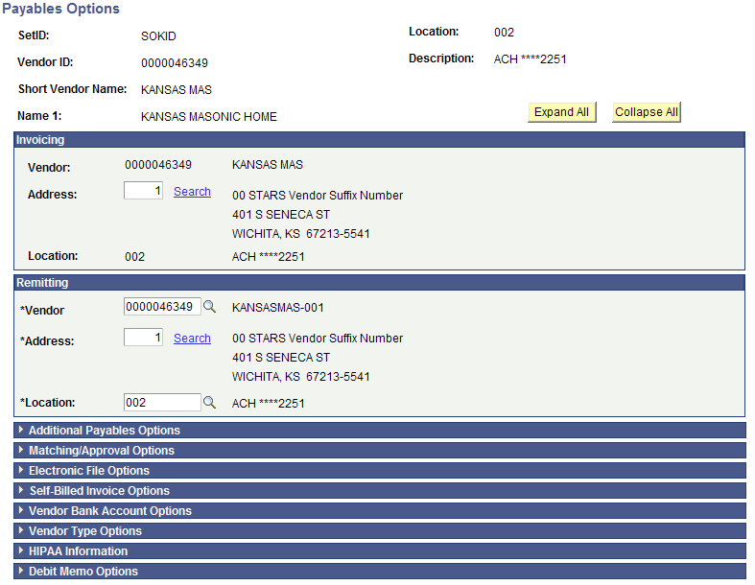
Figure 3.31. Payables Options page – Additional Payables Option section (Outlined)
- In Additional Payables Option under Additional Payment Information, select “Specify” and “Automated Clearing House” from the drop down boxes beside Payment Method.

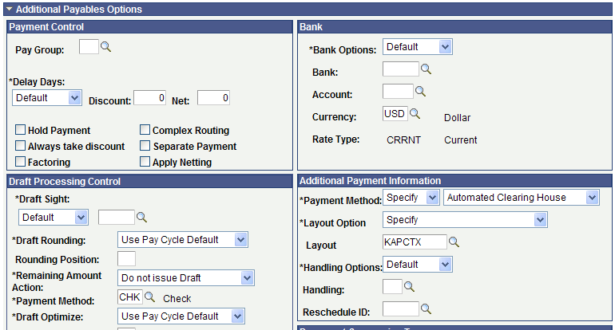
Figure 3.32. Additional Payables Option - Additional Payment Information Section (Outlined)
- Click on the Expand Section button (triangle button to the left of the title) for the Vendor Bank Account Options section.
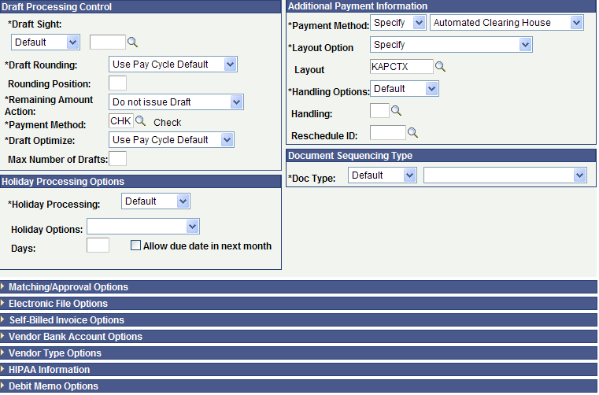
Figure 3.33. Payables Options page – Vendor Bank Account Options section (Outlined)
- Enter the Vendor Bank Account information from the DA-130 and the voided check (if obtained for an individual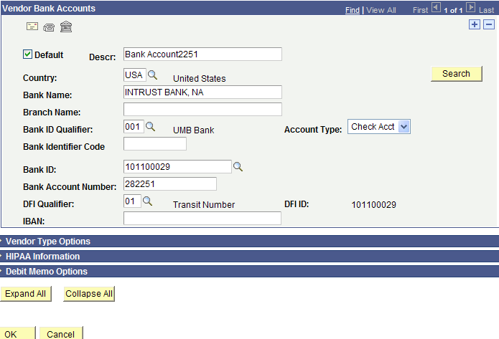
Figure 3.34. Vendor Bank Accounts Section and OK button (Outlined)
- Click the OK button.

Next, you need to complete the 1099 information. Click on the 1099 link.
Figure 3.35. Vendor Location Page – 1099 Link (Outlined)
Save the vendor record before exiting the record

Don’t forget to send the additional information Forms to the Central Vendor Processor via email !

